Educational Attainment and Non-linear Correlations with Altruistic Behavior:

An Analysis of Current Population Survey Microdata, 2009-2013

Samuel Showalter

DePauw University

November 15, 2015

***Abstract:*** *Substantial research has correlated education level with increased participation in altruistic pursuits. However, the nature of educational attainment’s relationship with volunteerism remains relatively unexplored. By examining Current Population Survey Microdata, this paper attempts to discern if different types of education contribute more heavily to annual volunteering hours than others. Regression estimates suggest that degree completion generally corresponds to a higher volunteer participation, relative to those who attend—but do not graduate—school. Similarly, while higher education does appear correlated with higher volunteerism, these levels appear to peak with the acquisition of a master’s degree, waning with those exhibiting professional or doctoral attainments.*

**I.** **Introduction: Volunteerism and its Importance**

Thought to increase personal happiness as well as provide a substantial contribution to the United States’ economy, altruism of all kinds is sought after and highly encouraged in today’s society. As a result, the inclination for individuals to volunteer has been a consistent topic of economic research for several decades. However, only 25.3 percent of people in the United States volunteer, begging the question as to why individuals do not partake in such a mutually beneficial activity (Bureau, 2014). As a result, many economists have sought to discern personal characteristics correlated with philanthropic tendencies. Since the 1960s, a multitude of publications have examined one predictor variable after another. Even so, much is still unknown about volunteerism contributions; it is likely that individual altruism arises from a combination of hundreds—if not thousands—of intra- and interpersonal factors.

Of these factors, an individual’s level of education is typically considered positively correlated with volunteerism. However, the author found no research highlighting education level’s relationship with altruism specifically. Accordingly, this paper endeavors to determine whether education level’s impact on volunteerism is non-linear; if so, the major educational contributors to civic participation will be detected and analyzed. Education level is commonly included in econometric analyses of volunteerism; it is hoped that through this paper, insights regarding the most appropriate ways of regressing education may be gleaned.

Therefore, the remainder of this paper intends to first highlight the findings of previous altruism research. From here, considerations regarding psychological and philosophical theory on why individuals volunteer will also be explored. These postulates will be crucial to interpreting OLS and PWLS regression results with Current Population Survey data.

**II. Literature Review: Notable Contributors to Altruism**

Evidence from prior research positively correlates volunteering with higher personal income and life satisfaction, as well as the economic health of a society overall. As expounded on by Day et. al. (1998), the “payoff of work without pay” can be quantified. According to their evaluation of the 1987 Survey of Volunteering Activity, volunteers possess, on average, an income 7% higher than their non-volunteering counterparts, holding other variables (age, race, gender, etc.) constant (Day et. al., 1998). For many, a 7% percent raise is equivalent to several thousand dollars annually, begging the question as to why more individuals do not volunteer. Often, volunteering is “a costly activity…in terms of time and…financially” (Day et. al., 1998). As a result, a 7% income jump for volunteers who—due to their philanthropic endeavors—are theoretically unable to work as much as their non-volunteer counterparts, is also practically significant. Theoretically, volunteering may raise income level and reduce time worked simultaneously. Day et. al. (1998) acknowledge the paradoxical nature of this volunteerism-earnings relationship, and hint that immeasurable variables (e.g. personal drive, empathy) may be influencing data. Though Day et. al. (1998) attribute this income jump to a cultivation of marketable skills through service, they acknowledge such an assertion is unverified.

Furthermore, as Meier et. al. (2008) illustrate with data collected from the German Socioeconomic Panel (GSOEP), individuals who volunteer tend to maintain a higher life satisfaction than those who do not. Survey results collected in Germany from 1985 to 1999 found that, on average, those who volunteer weekly witness a life satisfaction composite rating (from 1 to 10) 0.295 points higher than those who do not volunteer at all, ceteris paribus (Meier et. al., 2008). By comparison, married individuals sustain an average life satisfaction composite 0.253 points higher than their unmarried counterparts. In light of volunteerism’s substantial contribution to life satisfaction, Meier et. al. (2008) cite prestige, “social approval,” and “intrinsic enjoyment” as principal contributors to increased happiness (for more information regarding altruism theory, see Theoretical Considerations). Indeed, the impact of volunteerism on life satisfaction and personal wellbeing is not only statistically significant, but robust across a variety of other causative factors, including (but not limited to) divorce, wage rate, and employment.

Analogously, many studies consider the volunteer labor force to be a large benefactor to a nation’s Gross Domestic Product (GDP). As Pho (2008) explicates and supports with his analysis of the 2005 Current Population Survey (CPS), “a number of studies have estimated the value of volunteer labor in the U.S. at between 1.5 and 6 percent of DGP.” Corroborating these claims with his own inquiry, Pho (2008)—taking a multifaceted, opportunity cost approach to evaluating volunteerism—converted hours volunteered into contributed capital via estimates of average wage (given the characteristics of the industry and the volunteer). His results denote that—based on the 2005 CPS sample data—the financial equivalent of volunteer contributions is likely between $116 and $132 billion dollars, or “0.9 and 1.3 percent of 2005 [United States] GDP” (Pho, 2008). Even when considering the derivation of Pho’s study from previous evaluations, volunteer labor represents a substantial portion of GDP; hence, volunteer labor within a nation remains crucial to personal, financial, and economic health. Subsequently, economists have examined various personal characteristics and their ties to volunteerism for decades. A brief synopsis of the similarities and differences in existing research is as follows.

Likely due to the complex relationship altruism has with personal attributes, a wide variety of econometric analyses exist for volunteerism. However, generally speaking volunteerism research can be categorized as an interpretation of the impact religiosity, industry of employment, core demographics (age, race, sex. etc.), spousal influence, or union membership, has on philanthropic participation rates (Segal et. al., 2002). Similarly, it is quite common for econometric models to regress many of the same predictor variables in an effort to minimize confounding; altruism research tends to vary with regard to researcher goals and variables interpreted, rather than the nature of analysis in general. Holistically, econometric investigations of volunteerism typically involve Ordinary Least Squares OLS regression analysis (e.g. Day et. al. (1998)), probit and logit analyses (e.g. Vaillancourt (1994)), or tobit and togit analyses (e.g. Segal et. al. (2002)). Predictor variables included in the models aforementioned tend to vary not with regard to inclusion or exclusion, but in the nature that they are regressed and interpreted.

To give an example, when examining union affiliation’s impact on charitable involvement, Zullo (2011) treats education as a single, continuous variable; such an action implies that for each additional year of education achieved by an individual, time donations (in hours) will increase by (a constant) 10.6%. Conversely, Day et. al. (1996)—in their analysis of core demographics on annual volunteer rates—includes education in their regression as a collection of dummy variables (e.g. some college, university degree). In doing so, Day et. al. (1996) allow education to exist as a non-linear relationship with volunteerism, given such a relationship exists in reality; in fact, such a practice appears necessary. When all other variables are held constant, a university degree increases annual volunteering, on average, by 71.82%, while a high school degree increases annual volunteering by only 36.37%. Reinforcing the notion that education’s contribution to philanthropic participation is non-linear, Bureau (2014) summarizes volunteer percentages, given educational attainment, for the 2014 CPS in Figure 1. Indeed, though these percentages are certainly confounded by omitted variables (no other correlated variables are held constant), it still appears likely that as of September 2014, education possessed a non-linear relationship with volunteer participation levels.

Figure 1.

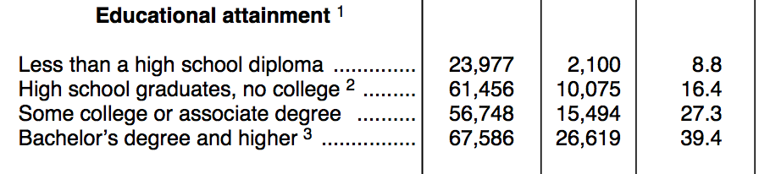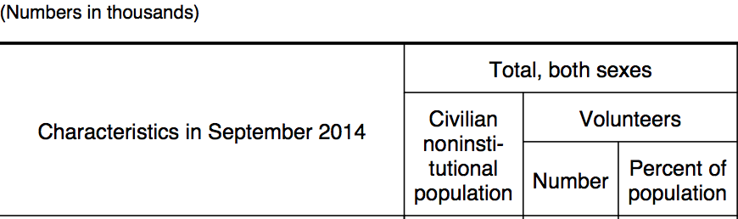

Generalizing this concept, the nature in which predictor variables are included in a regression implicitly determines the conditions of their interpretation. Apparent from the previous example, education as a predictor of altruism is no exception. Generally, the two common methods used to capture education’s impact on volunteerism are creating dummy variables for major educational attainments (e.g. some college, college degree, masters degree) and allowing education to exist as a single, continuous variable. Of these methods, the former is utilized markedly more often in existing research, though researcher impetus regarding the use of either method is typically unaddressed. As an exception to this rule, Day et. al. 1996 inculcates in coordination with their data, “university degree [attainment] has a significant impact on hours” donated, more so that any single year of education. Vaillancourt (1994) and his analysis of education corroborates Day’s claim. University graduates witnessed a volunteer participation increase of 79.8% versus a 29.4% increase for high school graduates. Even so, discussion of the volunteer participation disparities between degree attainments and education levels could not be found (Vaillancourt, 1994).

Thus, though current econometric research concerning volunteer participation includes several quantitative analyses of education, often the interpretation of education’s impact is scantly addressed or overlooked all together. As proposed by Day et. al. (1996), the lack of focus on education is possibly due to a general acceptance by researchers that “the propensity to volunteer …increases with education.” Though such an assertion is likely legitimate, it does not undermine the importance of determining if the “degree[s] received” by an individual impact volunteer levels disproportionally, compared to “level[s or years] of school completed” in general (Rotolo et. al., 2006). Existing research analyses tend to maintain a common consensus with regard to education’s non-linear relationship, but the nuances of said relationship appear relatively unexamined. Subsequently, the primary focus of the author’s research is to confirm education’s non-linear contribution to volunteerism; if strong evidence supporting non-linear confirmation can be gathered, the patterns of education’s altruism impact will be examined to identify educational attainments that contribute most heavily to volunteering hours.

**III. Theoretical Considerations: Altruism Theory and Utilitarianism**

Of the theories that scrutinize personal motivations for engaging in altruistic pursuits, two schools of thought dominate. The older of the altruism theories—pioneered primarily through Aristotle’s *Nicomachean Ethics*—dictates, “true happiness is…found in the expression of virtue” (Meier et. al., 2008). People endeavor to help and assist others purely because it is their nature to do so and an affirmation of their ethical code. Donating one’s time allows an individual to exercise their moral character as well as empathize and derive pleasure from the assistance he or she is providing. Based on this view, “a happy person is a moral person,” and volunteerism is tied directly to a greater life satisfaction (Meier et. al., 2008). Though evidence exists to corroborate the claim aforementioned (see Literature Review), it has been difficult for researchers and psychologists to identify the mechanisms by which civic engagement and moral action transform into intrapersonal happiness and satisfaction.

One proposed mechanism, as noted briefly by Meier et. al. (2008) and substantiated empirically by McBride (2009), is the aspiration theory of happiness. Aspiration theory states that happiness is dependent on both aspirations and outcomes. If one’s goals are consistently lofty or unattainable, an individual is more likely to maintain a lower happiness level even if their situational outcomes are favorable. Conversely, if one’s aspirations are consistently low, but outcomes are analogously unfavorable, individuals are again less likely to be content with their life (McBride, 2009). According to McBride (2009), increasing aspirations have a “negative and statistically significant impact” on happiness level, while decreasing outcome success does the same, for obvious reasons. As a result, an individual’s happiness can be mapped by Figure 2, where *h* represents happiness level, *y* represents outcome success, and *a1* and *a2* represent different aspiration levels (*a1* < *a2*) (McBride, 2009).

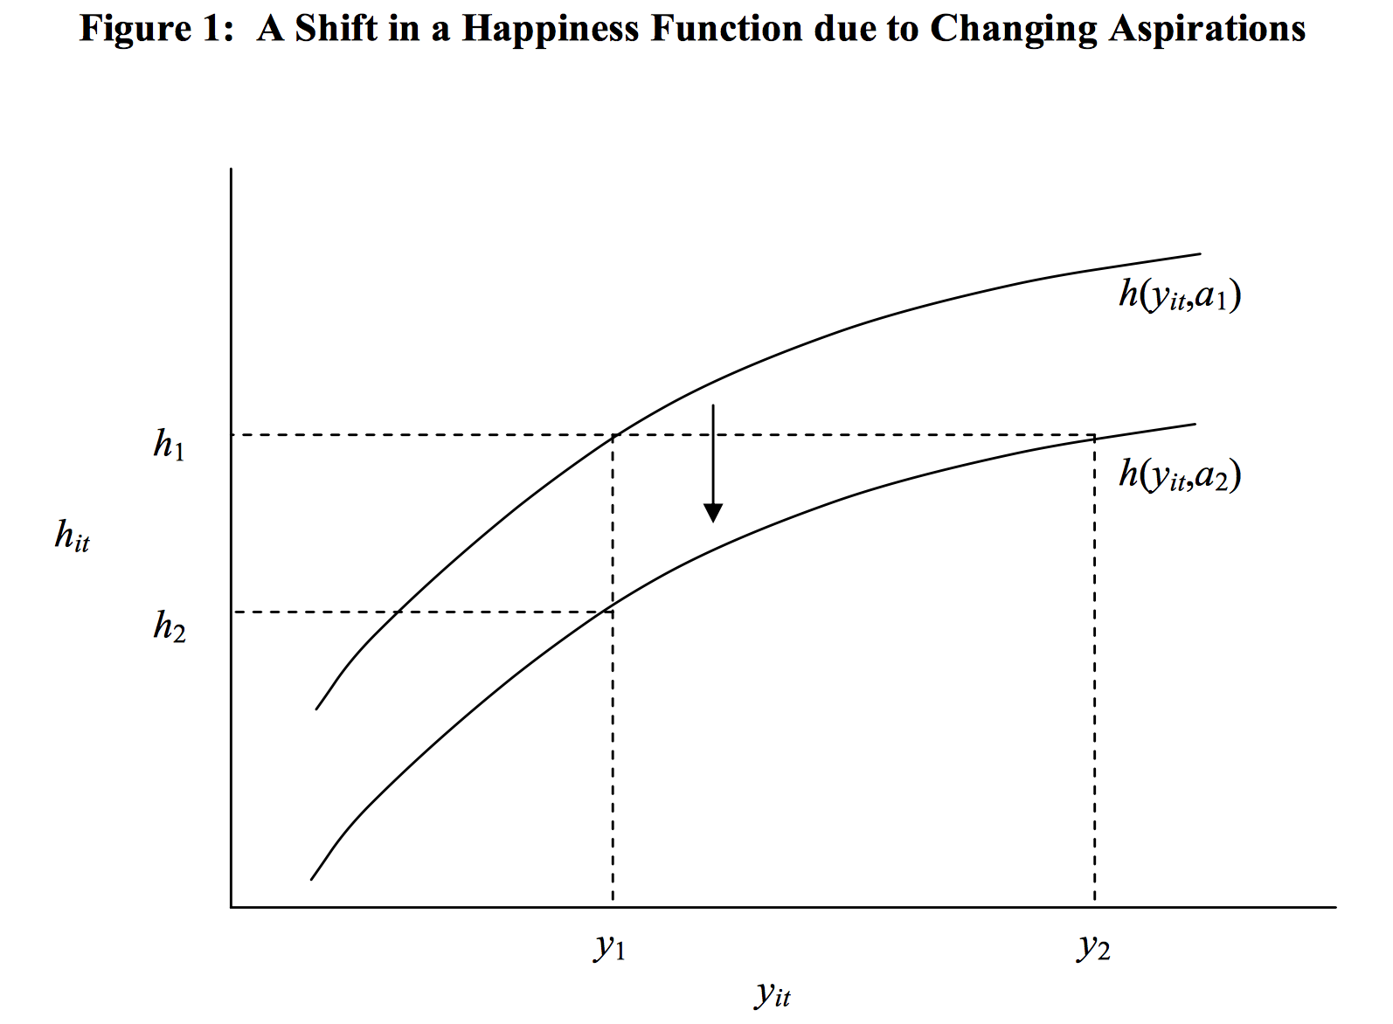

Figure 2.

As seen above, aspiration level has increased from *a1* to *a2*. In comparing these differing aspirations, *a1* derives greater pleasure from his or her actions. Indeed, in order for *a2* to match the happiness level *a1*, outcome success level must jump from *y1* to *y2*.

Shifts in aspiration level can arise as the result of many factors, including historical outcomes, outcomes of those proximal to the individual, and intrapersonal expectations (McBride, 2009). Along with these three main manipulators of aspiration level, McBride (2009) hints that activities like volunteering may play a role in regulating aspiration levels, possibly by spurring introspection; that is, perhaps by humbling one’s self through payless service, an individual may be more prone to self-assess their actions and goals. In doing so, aspirations are more likely to be formed realistically and, in turn, life satisfaction may increase. Therefore, as McBride (2009) inculcates repeatedly, “satisfaction levels…depend on aspiration levels as well as outcomes.” Through the lens of aspiration theory, altruism may assuage the creation of naive aspirations and lead to greater happiness overall.

By contrast, a more current and commonly referenced theory of altruism is Jeremy Bentham and John Stuart Mill’s concept of utilitarianism, where individuals inherently “pursue their narrow self interest” (Meier et. al., 2008). Thus, the moniker *Homo Economicus* was coined to describe an individual who exists to “maximize his utility by behaving selfishly,” even if his or her actions benefit society overall (Meier et al., 2008). Utilitarianism differs from Aristotle’s morality theory as it denotes that virtuous action is not the root cause of happiness; an individual’s utility is bolstered by witnessing his or her actions increase the utility of others. From this perspective, volunteering can be considered a “hedonistic way of seeking pleasure and happiness solely for one’s self” (Meier et al., 2008). Though much of this statement could be connoted negatively, it is without warrant; if the prior assertions are legitimate, a strong argument can made that hedonistic actions can (and do) benefit society at large.

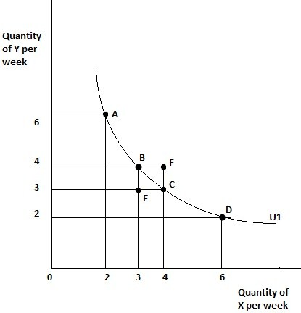 Due to the abstract nature of Utilitarianism, a visualization of the theories application to volunteerism is provided by the Figure 3 below, which displays a hypothetical utility curve. This curve is purely for visualization purposes, and is not comprised of gathered data.

Figure 3.

Here, *X* represents the number of hours spent volunteering in a given week, while *Y* represents the number of hours spent working and earning money. Subsequently, *U1* represents a utility curve, where all of the combinations of time spent volunteering or relaxing intersected by *U1* translate to the same level of happiness or satisfaction. Now, if an individual wished to attain the utility level of *U1* purely through work (or the earnings thereof), the amount of hours necessary would be enormous due to the Law of Diminishing Marginal Utility (and practicality). At the same time, it would also take an exorbitant amount of volunteering hours to achieve *U1* satisfaction as well. Therefore, intrinsically utilitarian individuals will choose the combination of volunteering and work that achieves utility level *U1* in the least amount of time (points *B* or *C* on the graph). It is from this utility model that the theoretical model for education was derived, as it is much more “conducive for econometric analysis” (Meier et. al., 2008).

Thus, with the Utilitarianism model in mind, education’s impact on volunteerism can be boiled down to examining satisfaction levels, given different combinations of activities. From an intuitive standpoint, individuals who have a lower education level are more likely to have a lower income, increasing their odds of working longer hours and having difficulty procuring basic necessities. Due to the increasing likelihood of these events as education level drops, those with less education will likely maintain utility curves that favor working over volunteering, reducing volunteer rates or eliminating them all together.

More contextually, uneducated, impoverished individuals may sincerely enjoy volunteering, but if their participation prevents them from earning money for food, their overall utility will be greatly reduced by their altruistic pursuits. Indeed, the methods by which individuals increase their subjective well being surely vary across different education levels. However, changes to volunteerism-derived utility are expected to be subtler when comparing specific education levels individually instead of in large groups. Therefore, it is necessary for education to be considered both as a single variable and a collection of dummy attainments to identify the relationship between volunteer participation and education level.

**IV. Empirical Analysis**

***IV. i. Collection and Refinement of CPS Volunteer Supplement Survey Data***

Before modeling the attributing factors that influence annual volunteering hours, however, these dependent variables need to be identified. By considering the included variables of previously mentioned publications—as well as other characteristics thought to contribute to altruistic tendencies—a variable list was specified. Of those selected, each was categorized under core demographics, occupation and income, and miscellaneous. All variables listed were first checked to ensure their availability in the CPS Volunteer Supplements of 2009 through 2013, as the data modeled in this analysis was collected from these surveys (Note: all nonresponse or “Not in Universe” data was omitted unless specified otherwise).

Core demographics encompass the variables of age, race, marital status, disability status, family size, and education level. As noted by the CPS, age at the time of survey completion was recorded; however, young children are highly dependent on their parents (Miriam et. al., 2010). As a result, this analysis only includes individuals older than sixteen to prevent this dependence from confounding data. Conceptually, it is likely that age may impact volunteerism non-linearly; personal values change substantially with age. To compensate for this, Age Squared will be created to observe any nonlinear interactions between age and volunteerism.

Likewise, race—which is denoted as a self-identification of one’s racial background—includes well over ten different strata, including multiple combinations of core races. In turn, since racial influence on volunteering is not the focus of this analysis, three racial dummies—White, Black, and Asian—were created from the original data to embody the impact of race. Hispanic was also included, but exists as its own variable, as an individual can be any of the races above ands also Hispanic. Moving forward, only those who identify exclusively as one of these races were included in the regression, with other races (and combinations thereof) omitted as a base case using Stata. Even so, White, Black, and Asian comprise identifications for over 95% of the sample. Disability has a variety of definitions defined by the CPS, including mental and physical hindrances of all kinds. However, disability is incorporated in this regression as a dummy variable recognizing any type of personal difficulty as a disability. In turn, the effect of the CPS’s disability strata is encapsulated by the disability dummy variable.

Moreover, marital status includes over five classifications, though the statuses of married, single, and divorced comprise over 95% of the sample. Regardless, all marital statuses include over 1500 observations, and are accordingly included in the regression as dummy variables. Due to strong evidence provided by Rotolo et. al. (2006) that married individuals volunteer more than any other marital status stratum, married individuals are omitted from the analysis as a base case. Now, family size—the number of family members living in one’s household—will also be considered in these regressions due to the time and financial commitments of raising a large family, as well as the general attitudes and values different sized families may maintain. Due to small number of observations, family size has a forced maximum of eight individuals. Much like education, it is also likely that the impact of family size on volunteerism is nonlinear in nature; intuitively, a single college graduate lives a very different life than a new mother, who lives a different life than a single father of five. Therefore, Famsize Squared was created to witness the impact of family size more dynamically (Miriam et. al. 2010).

Lastly, education level—the keystone of this examination—was considered in multiple ways. First, the CPS provides education as fourteen different strata, ranging from no education/preschool to Doctorate degree attainment. From these strata, new variables are formed to embody the event of major educational milestones: completing elementary school, receiving a high school diploma, attaining a Bachelor’s degree, and so on. Finally, educational data from the CPS was recoded so that each level of education translates to the number of years it took attain (Model (1)). Through this recoding, education can be treated as a single, continuous variable with regard to regression analysis. Analogously, major educational milestones will also be regressed exclusively, as if the only impact education has on volunteer participation occurs at the culmination of major attainments (Model (2)). Those that did not complete elementary school were omitted as a base case. Lastly, all education levels of CPS will be included as dummy variables in Models (3) and (4); individuals with lower than a fourth grade education were used as a base stratum. Comparisons between these models may yield insights on how education contributes to altruistic tendencies, holding other included variables constant.

Transitioning to occupational and income related variables, employment status, weekly earnings, occupation sector identification, union affiliation, and weekly hours worked are scrutinized. Employment status is defined by the CPS as “whether persons were part of the labor force…and, if so, whether they were currently unemployed” (Miriam et. al. 2010). Consequently, for this model, only individuals residing in the labor force are included. Therefore, the impact of employment status can be embodied by an employment dummy variable. Due to a correlation between nonresponse data values and employment status, roughly 28% of the sample is comprised of unemployed individuals. At the same time, an assumption regarding weekly earnings and employment status was made for the following reason.

Of the five CPS Volunteer Supplement surveys, roughly 75% of those surveyed had responses for weekly earnings considered to be not in the universe (niu) of the variable. The universe of weekly earnings is defined by the CPS as “civilians 15+ currently employed as wage/salary workers.” To reconcile the universe of weekly earnings without removing all unemployed observations, all unemployed individuals with an niu response to weekly earnings were assumed to have no weekly earnings, as they are not working currently (Miriam et. al. 2010). All other niu observations for weekly earnings were dropped. Also, the survey questions regarding weekly earnings do not discern between wages greater than $150,000 annually. To avoid confounding regression results, all observations with earnings equal to or greater than $150,000 were omitted. Of the remaining observations, weekly earnings is considered to be a continuous variable (in USD), as seen in the histogram below. For the sake of clarity, a histogram and description of annual hours spent volunteering will be inserted below. This histogram has been truncated to match the scale of the weekly earnings histogram; the first bin of volunteering hours extends to just beyond 0.01 on this density histogram.

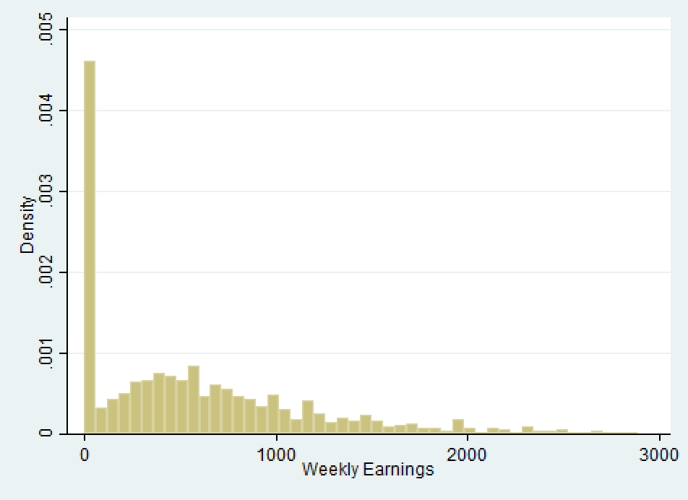

Figure 4.

The annual hours volunteered variable—much like weekly earnings—was riddled with niu observations, as the CPS defines the universe of annual hours volunteered as “persons age 15+ who had volunteered in the past year” (Miriam et. al. 2010). Again, to prevent the omission of all individuals who do not volunteer (73% of the population) from the sample, a few assumptions were made. First, by utilizing self-reported volunteer status information from the CPS, individuals who identified as non-volunteers were given an annual volunteerism value of zero hours. Correspondingly, self-identified volunteer observations were dropped from the dataset; no information can be gained about their volunteering endeavors. When observing the distribution of annual volunteerism overall, a right-tailed distribution is visible, with frequencies decreasing fairly consistently as hour levels increase. It is the ultimate goal of this analysis to determine if the individuals represented at the right end of the histogram share any common characteristics with regard to education, ceteris paribus.

Returning now to occupational and income characteristics, the sector in which an individual works appears to have a significant bearing on philanthropic tendencies. As evidenced by Segal et. al. (2002), those who work for the government or a bureaucratic affiliate therein tend to volunteer significantly more that their private sector counterparts. In turn, the sector a worker’s occupation resides in was incorporated as two dummy variables, government and private sector. These were incorporated in the regression as dummy variables and compared to individuals who were self-employed, the omitted base case. The universe for worker sector includes “persons 15+ who have ever worked,” so no assumptions or edits will need to be made to refine the data, as opposed to weekly earnings and volunteer hours (Miriam et. al., 2010).

Similarly, union membership also seems to increase individual volunteer contributions, as asserted by Zullo (2011) and mentioned previously. In turn, CPS union membership data was included in the original dataset and recoded act as a dummy variable. Non-union observations were omitted as a base case. Now, the universe for union membership was constructed as “Civilians 15+ currently employed as wage/salary workers” (Miriam et. al., 2010). To resolve niu union responses without omission of the unemployed portion of the dataset, individuals currently unemployed were assumed to not be a member of a union. Other niu responses aside from those aforementioned were omitted. Since it is possible for individuals to be unemployed and still affiliated with a union, this assumption is the least sound of those asserted in this analysis (Zullo, 2011). However, due to the fact that the occurrence aforementioned is rather rare —coupled with the fact that union membership is not the focus of this analysis—the assumption is not expected to greatly impact output (Zullo, 2011).

Along the same lines, weekly hours worked is likely to play a role in determining individual volunteerism. Those that work an archetypal 40-hour week will have more time to devote to civic engagement than an investment banker working in excess of 100 hours weekly. In turn, weekly hours worked represents a time count of salaried for wage work hours. As with weekly earnings and others, the universe of weekly hours worked poses an issue, as it is defined to be “Civilians age 15+, at work last week” (Miriam et. al., 2010). Subsequently, individuals who are unemployed are assumed to work zero hours weekly. Other niu observations outside of these criteria are dropped from the sample. This way, one can more candidly determine what the impact an additional hour worked a week will have on annual volunteer hours, ceteris paribus.

Changing pace, miscellaneous variables include necessary facets of the regression that account for variation across time and geographic location. Nine region dummy variables that split up the United States are included in the following regressions to denote regional volunteering trends (New England Division removed as a base case). At the same time, since popular sentiment and mass media may influence volunteerism, it is prone to change over time. To compensate for this possibility, five dummy variables for years 2009 through 2013 were also included in the regression (2009 was omitted as a base case). These variables are important for regression analysis as a whole, but not for the practical purposes of this paper; consequently, these variables are omitted from regression results and interpretation. With the dataset now collected and refined, summary statistics for each variable are displayed in Figure 5 below, and regression analysis may begin. “Highscho…” denotes the status of receiving a high school diploma and “has diffi…” represents the presence of a disability.



Figure 5.

Before delving into regression results and interpretation, however, a few general considerations regarding omitted variables will be addressed. First and foremost, the possibility (and indeed probability) that variables correlated with included regression variables are omitted is cause for genuine concern. If such an event does occur, the econometric models will be subject to the deleterious effects of omitted variable bias, consequently confounding correlated variables. With that said, the author has done everything in his power to ensure such an occurrence does not happen by including all predictor variables thought to be correlated with one another. Even so, variable restrictions as a result of the finite amount of volunteer survey data does pose the risk of omitted variable bias. It was hoped that a measure of cumulative individual and family wealth would be available, as weekly earnings fluctuate over time and does not lend as much insight into the financial security of an individual. Alas, it was not a question asked in the Current Population Volunteer Survey. Likewise, religious affiliation—also thought to impact volunteerism (see Segal et. al., 2002)—was unavailable. Despite these setbacks, the dataset utilized is nuanced and thorough in spite of the restrictions of the CPS.

***IV. ii. OLS and PWLS Regression Analysis of Volunteerism and Education***

In total, four regressions were completed, with small manipulations of education variables distinguishing them. All regressions will be examined at length individually, but it is valuable here to mention the overlying purpose of each. Seen in Figure 6, Model (1) treats education as a single continuous variable quantified by the number of years an individual spends in school. At the same time, Model (2) represents education as a series of educational attainment dummy variables. Elaborating even further, Model (3) includes all levels of education provided by the CPS as dummy variables. Models (1) through (3) are OLS regressions. Yet, these samples need to be weighted; the CPS utilizes complex cluster-based sampling techniques. To compensate for this, weights are assigned to each observation, and a Probability Weighted Least Squares (PWLS) Regression of Model (3) is run in Model (4).



(Standard Errors Robust)

Figure 6.

Focusing on the results of Model (1), OLS regression results denote that holding all other included variables constant, one additional year of education will increase annual altruism by 5.346 hours. All other variables mentioned in the previous section were also included to allow adequate comparisons between different education models. Dropping other variables inhibits these comparisons by inducing omitted variable bias. Education’s coefficient result is fairly consistent with hedonistic (utility maximizing) altruism theory—individuals who can afford the time to volunteer (because of higher education and, in turn, higher wages) do so more often, as it increases their life satisfaction. With that said, it is fairly unlikely that the transition from fifth to sixth grade is as influential on volunteer participation as completing one’s senior year of college. Also, it is important to acknowledge the R2 of the regression is quite low at 0.019. This is not necessarily a cause for concern; cross sectional data is notorious for this issue, especially with regard to regressions involving volunteer hours. Indeed, the volunteer hours regression completed by Day et. al. (1996) maintains an R2 value of 0.0462 with almost double the amount of predictor variables.

To further inspect the unequal influence education postulate, Model (2) was regressed. Here, education is thought to solely impact civic engagement levels through school completion or degree attainment. That is, if an individual graduates high school, but attends college and does not graduate, their volunteerism levels would be attributed to their high school diploma attainment, and not their time spent in college. From the lens of this model, incomplete education beyond an individual’s highest degree attainment has no impact on volunteer participation. With this in mind, individuals who completed elementary school volunteered, on average, 2.808 hours more than those who did not complete elementary school, ceteris paribus.

Figure 7.

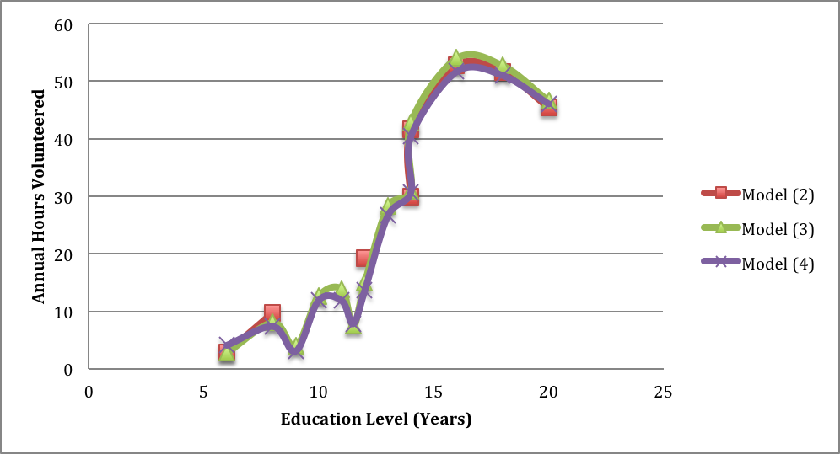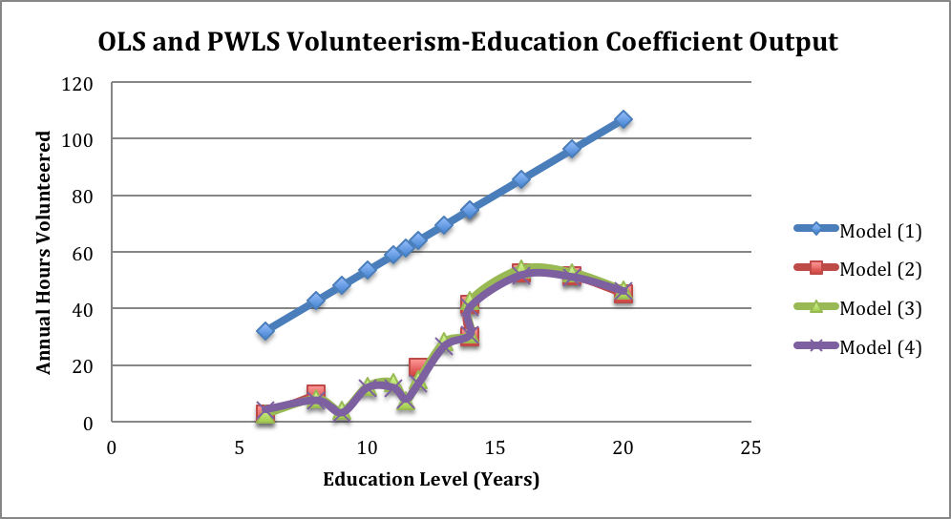

All education coefficients in this model are relative to the volunteer participation of those who did not complete elementary school, and can be compared accordingly. If middle school is completed, volunteerism jumps to 9.646 more hours annually, ceteris paribus. High school degree attainment adds an even larger jump, with around 19.17 more annual volunteer hours.

Additionally, an associate’s degree—the next educational attainment possible time-wise after high school—sports a 29.85 annual volunteering hours boost, an increase comparable to the difference between middle school education and high school diploma volunteerism coefficients. Regarding a bachelor’s degree—with a volunteerism coefficient of 41.53 hours annually—the increase from an associate’s degree is again comparable, though slightly larger than previous jumps in volunteerism at 11.68 more hours annually than those with associate’s degrees. A master’s degree too exhibits a similar increase, with 11.15 more annual hours volunteered than those with a bachelor’s degree. With a coefficient of 52.68 volunteer hours more than those who do not complete elementary school, the educational contribution of a master’s degree represents the apex for volunteer participation across all other educational attainments.

Professional degrees maintain an annual volunteerism level of approximately 51.51 hours annually, a slight decrease from master’s degree individuals. In turn, a doctorate degree—the longest educational time commitment at approximately twenty years—depicts a more pronounced decrease, with a volunteerism coefficient of 45.30. These trends in volunteerism contributions by education can be seen in Figure 7 above. In this figure, Models (2) through (4) coefficients exist as dummy variable output, but to visually compare these with Model (1), dummy education attainments were quantified through the same process used to recode education as a single variable. Figure 7 does indeed appear to connote that—holding all other included variables constant—educational contributions to volunteerism plateau and eventually decrease after attaining a master’s degree. More importantly, however, all formal educational attainment-volunteerism coefficients in Model (2) are statistically significant a 0.1% significance level, aside from completing elementary school. When holistically interpreting Model (2), results suggest that formal scholastic completion plays a major role in determining altruistic tendencies.

Nevertheless, in an effort to further corroborate these preliminary claims, Models (3) and (4) will be examined. In essence, these two regressions interpret the same data, though Model (4) assigns weights to different observations based on how rare the observations are in a population. The more extraordinary a data point is, the more it is weighted; also, robust standard errors cannot be determined for PWLS regression. Thus, Model (3)—instead of categorizing individuals based on their highest formal educational attainment—considers an individual’s highest level of education, formal or not. Through this variable framework, one can determine if individuals who did not graduate from their highest level of education attempted share any common altruistic traits. Unfortunately, the main variables available through the CPS were pre-high school data (grades 7-11) and the variable “Some College.” No data was available regarding individuals who attempted to, but did not attain, masters, professional, or doctorate degrees. Even so, the results found were both notable and surprising.

Volunteerism coefficients for individuals who attained a 12th grade education or less fluctuate substantially, with estimates jumping between 2.773 (Grades 5 or 6) and 13.81 (Grade 11) annual hours more than those who did not attain a 5th grade education or higher. Volunteer participation coefficients spike with individuals attaining 7th or 8th grade education to 8.021 hours annually, only to drop to 3.867 hours with the fulfillment of a 9th grade education. Though the cause of this occurrence is unknown, such a precipitous drop in volunteer participation hints that degree attainment and school completion may play a larger role in determining altruistic tendencies than simply attending school. Substantiating this claim, the volunteer participation coefficients for individuals with a 9th, 10th, 11th, or 12th grade (no diploma) education (3.867, 12.60, 13.81, and 7.439 annual hours, respectively) all reside below the volunteerism coefficient of high school graduates, standing at 14.91 annual hours.

Also, the volunteerism coefficient for individuals who attended—but did not graduate— college (28.18 annual hours) stands below that of its associate and bachelor’s degree counterparts (30.83 and 42.69 annual hours, respectively). More notably, all coefficients for education levels at or above a high school diploma are statistically significant at a 0.01% significance level. Conversely, aside from a 10th or 11th grade education (1% and 0.1% significance, respectively), no volunteerism coefficients for education levels below high school graduation are statistically significant at all. It appears that—generally speaking—altruism habits among 12th grade high school dropouts and pre-high school students are more variable and difficult to account for than those of their post-high school counterparts. Perhaps this variation could be attributed to living in the same house as one’s parents (as is common of pre-college students), or common characteristics between high school dropouts. In any case, it is impossible to know definitively from this data (see Conclusion and Further Research).

Another prominent comparison between Models (2) and (3) can be seen when comparing their volunteerism coefficients for educational attainments. Model (2) appears to overestimate the impact educational milestones and degree achievements have on education. Model (2) attributes an increase of 19.17 annual hours donated to receiving a high school diploma, while Model (3) denotes a comparably smaller increase of 14.91 hours. It appears that the omission of pre-graduation education variables in Model (2) may have confounded the true impact graduating high school has on volunteering rates. This trend is also witnessed in middle and elementary school volunteerism coefficients. Consequently, though formal school attainments may contribute more heavily to annual volunteerism overall, including variables pertaining to informal levels of education is a necessity if unbiased results are to be gathered.

Now turning to Model (4), coefficients relating to education are uniformly similar to those of Model (3), consistently varying by fewer than 2 annual volunteer hours (See Figures 6 and 7). Additionally, CPS data was collected via cluster sampling, and a PWLS regression accounts for this; OLS regressions manipulate data under the assumption that data was collected as a simple random sample. By utilizing an OLS regression on cluster-sampled data (outside of the parameters of the Classical Econometric Model), one inherently allows confounding and bias to corrupt point estimates. In light of these facts, Model (4) is considered to be more accurate than Model (3). Fortunately, the point estimates of Model (3) and (4) are nearly identical.

***IV. iii. Comparison and Significance to Prior Research***

The findings of this paper appear to affirm the use of including education as a series of dummy variables, including strata that do not represent significant benchmarks of the educational process. Therefore, the education interpretations of Day et. al (1996), Vaillancourt (1994), and others are reinforced. By contrast, the (less common) inclusion of education level as a continuous variable by Zullo (2011) appears to be a somewhat inappropriate representation of education. Similarly, though Roloto et. al. (2006)’s inclusion of only degree attainments for educational considerations is an improvement from Zullo (2011), it is possible that the coefficients found overstate the impact of degree attainment; non-attaining years of education surely have an (albeit smaller) effect on volunteering tendencies in an individual.

As a brief supplement, the non-educational coefficients of Models (1)-(4) proffer insight into the findings of previous research. For example, the findings by Rotolo et. al. (2006) that married individuals are more likely to volunteer are affirmed; with married individuals dropped as the base-case marriage variable, all other strata exhibit statistically significant negative coefficients (aside from widowed individuals, who surprisingly volunteer nearly as much as their married counterparts). At the same time, the government sector individuals appears to volunteer 5-7 hours more than their private sector counterparts, ceteris paribus, reinforcing the findings of Segal et. al. (2002). As a final finding that moves beyond prior research, females—across all models—were noted to volunteer four to five hours more than males, holding all other included variables constant. These findings were statistically significant for all models.

**V. Conclusions and Further Research**

The purpose of this econometric exploration of volunteerism contributors was carried out with the intention of determining the impact education level had on annual volunteer rates. More specifically, education’s impact was hypothesized to be non-linear, with the hopes of identifying specific facets of education that contributed most heavily to altruistic tendencies. Based on the OLS and PWLS regression results seen in Figure 6 and visualized in Figure 7, strong evidence affirms the notion that the impact of educational attainment is non-linear in its relationship to annual hours volunteered. In general, individuals who attain a degree or complete school volunteer more, on average, than those who did not (even if an individual completes their penultimate year of study). At the same time, annual volunteerism contributions are seldom statistically significant until an individual graduates high school, as mentioned earlier. Extensions of this analysis could pursue the contributors of childhood volunteerism more directly, perhaps with a focus on the impact of living at home and the altruistic tendencies of other family members.

In an analogous manner, the nature of education’s overall impact on volunteer participation (see Figure 7) denotes a few interesting trends. Indeed, the line connecting the altruistic impact of years of education conveys an “S” shape. Small volunteerism shifts give way to statistically significant volunteerism spikes after high school graduation, eventually peaking at a master’s degree and decreasing thereafter. These trends signify that the largest contributions by education to altruistic tendencies occur after the attainment of a high school degree and end with the attainment of a master’s degree.

Three major avenues of further exploration exist here. For one, data could be gathered on the volunteerism of those who failed to attain a post-undergraduate degree, to denote any fluctuations in the “S” shaped curve currently witnessed. Such data could lend invaluable insights into commonalities shared by individuals who attempted—but did not achieve—educational attainments. In an analogous manner, one could conduct probit, logit, tobit, and togit analyses to further scrutinize the nature of education’s “S” shaped impact on volunteerism and volunteer participation. The results of this examination would likely either affirm or refute the possibility that educational contributions to volunteerism increase most rapidly after high school and diminish with the attainment of a master’s degree.

Lastly, an investigation into the volunteer habits of post-undergraduate educated individuals may lend insights into why volunteer participation diminishes after a master’s degree. If volunteering is as beneficial to life satisfaction as asserted by Meier et. al. (2008), it is somewhat paradoxical that (likely) well compensated professional and doctorate degree holders refrain from such action. Further study may illuminate that hours worked is to blame in these instances; though, in this analysis, hours worked was considered to have a minimal and statistically insignificant impact on annual volunteer hours (-0.0726 fewer annual volunteer hours for every extra weekly hour worked, holding all other included variables constant, according to Model (4)). In any case, the findings of this paper lay a platform from which extensive education-volunteerism inquiry may occur.

**VI. References**

Bureau of Labor Statistics (2014). “Education and volunteering.” *The Economics Daily*. Retrieved from http://www.bls.gov/opub/ted/2008/jan/wk4/art03.htm

Day, K. M., & Devlin, R. A. (1996). Volunteerism and crowding out: Canadian econometric evidence. *Canadian Journal of Economics*, 37-53. Retrieved from http://www.jstor.org/stable/136150

Day, K. M., & Devlin, R. A. (1998). “The payoff to work without pay: Volunteer work as an investment in human capital.” *The Canadian Journal of Economics/Revue Canadienne D'economique*, *31*(5), 1179–1191. Retrieved from http://doi.org/10.2307/136465

Konow, J. & Earley, J. (2002). “The hedonistic paradox: Is homo economicus happier?” *Journal of Public Economics,* 92(2), 1–33. Retrieved from http://myweb.lmu.edu/jnow/hedonistic

McBride, Michael, (2009). “Money, happiness, and aspirations: An experimental study.” *University of California, Urvine.* Working paper*.* Retrieved from http://www.economics.uci.edu/files/docs/workingpapers/2006-07/McBride-21.pdf

Meier, S., & Stutzer, A.. (2008). “Is volunteering rewarding in itself?” *Economica*, *75*(297), 39– 59. Retrieved from http://www.jstor.org/stable/40071730

Miriam King, Steven Ruggles, J. Trent Alexander, Sarah Flood, Katie Genadek, Matthew B. Schroeder, Brandon Trampe, and Rebecca Vick. Integrated Public Use Microdata Series, Current Population Survey: Version 3.0. Minneapolis: University of Minnesota, 2010.

Pho, Y. H. (2008). “The value of volunteer labor and the factors influencing participation: Evidence for the United States from 2002 through 2005.” *Review of Income and Wealth*, *54*(2), 220-236. Retrieved from http://www.roiw.org/2008/2008-10.pdf

Rotolo, T., & Wilson, J.. (2006). “Substitute or complement? Spousal influence on volunteering.” *Journal of Marriage and Family*, *68*(2), 305–319. Retrieved from http://www.jstor.org/stable/3838902

Segal, L. M., & Weisbrod, B. A.. (2002). “Volunteer labor sorting across Industries.” *Journal of Policy Analysis and Management*, *21*(3), 427–447. Retrieved from http://www.jstor.org/stable/3325678

Vaillancourt, F.. (1994). “To volunteer or not: Canada, 1987.” *The Canadian Journal of Economics/Revue Canadienne D'economique*, *27*(4), 813–826. Retrieved from http://doi.org/10.2307/136185

Zullo, R.. (2011). “Labor unions and charity.” *Industrial and Labor Relations Review*, *64*(4), 699–711. Retrieved from http://www.jstor.org/stable/41343680